1. Give a big-Oh characterization, in terms of n, of the running time of the example1 method from Exercises class in Lesson 4 examples.

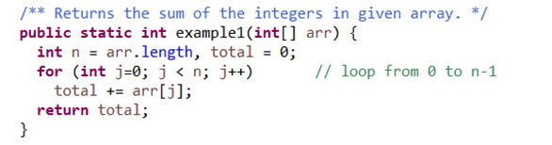

The running time is the size of array, which is n. This loop traverses the array. Thus, the running time is linearly growing as $O(n)$.

1. Give a big-Oh characterization, in terms of n, of the running time of the example2 method from Exercises class in Lesson 4 examples.

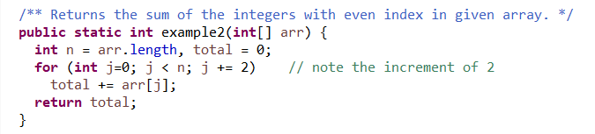

The running time is the half size of array, which is $\frac{n}{2}$. This loop traverses the array by the increment of 2. Thus, the running time is linearly growing as $O(n)$.

1. Give a big-Oh characterization, in terms of n, of the running time of the example3 method from Exercises class in Lesson 4 examples.

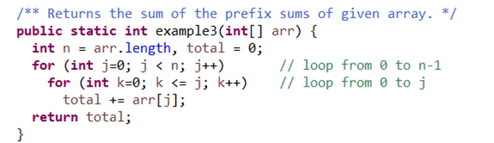

The first loop traverses the array, and the second loop traverses the array from the begin element to the current element. Two loops are nesting, so the running time is quadratic $O(n^{2})$.

1. Give a big-Oh characterization, in terms of n, of the running time of the example4 method from Exercises class in Lesson 4 examples.

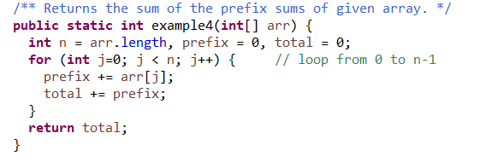

This example is essentially the same as example 1. Thus, the running time is linearly growing as O(n).

1. Give a big-Oh characterization, in terms of n, of the running time of the example5 method from Exercises class in Lesson 4 examples.

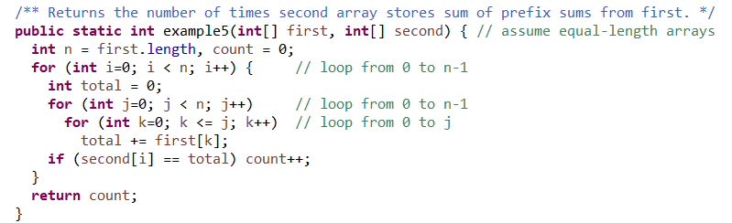

The first loop traverses the second array, and the second loop traverses the first array while the last loop traverses from the begin element to the current element of the first array. Three loops are nesting, so the running time is cubic $O(n^{3})$.